1. For this exercise, use the following modular arithmetic hashing function to find the index of the element in the hash table: *Hash(x) = x* mod 13.

**Start with an empty hashing table,** using Open Addressing with **Quadratic Probing**, show how the following table HT would look like after inserting the following elements in this order into the table: 7, 22, 27, 23, 24, 25, 37, 107,12,43, 18, 35. Show your work by filling the table below that should show how the hashing table will look like after adding every 2 elements to the table. (Please note that, if after 6 probes, an item can’t be inserted into the hashing table, leave it outside the table and mark that down)

|  |  |  |  |  |  |  |  |  |  |  |  |  |
| --- | --- | --- | --- | --- | --- | --- | --- | --- | --- | --- | --- | --- |
|  |  |  |  |  |  |  |  |  |  |  |  |  |
| 0 | 1 | 2 | 3 | 4 | 5 | 6 | 7 | 8 | 9 | 10 | 11 | 12 |

HT

**Answer:**

|  |  |  |  |  |  |  |  |  |  |  |  |  |  |
| --- | --- | --- | --- | --- | --- | --- | --- | --- | --- | --- | --- | --- | --- |
| After adding 7 and 22 |  |  |  |  |  |  |  |  |  |  |  |  |  |
| After adding 27 and 23 |  |  |  |  |  |  |  |  |  |  |  |  |  |
| After adding 24 and 25 |  |  |  |  |  |  |  |  |  |  |  |  |  |
| After adding 37 and 107 |  |  |  |  |  |  |  |  |  |  |  |  |  |
| After adding 12 and 43 |  |  |  |  |  |  |  |  |  |  |  |  |  |
| After adding 18 and 35 |  |  |  |  |  |  |  |  |  |  |  |  |  |
|  | 0 | 1 | 2 | 3 | 4 | 5 | 6 | 7 | 8 | 9 | 10 | 11 | 12 |

1. Given the following BST:

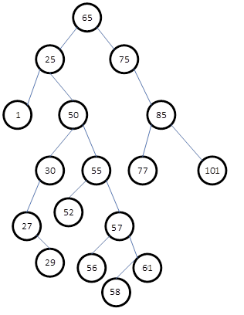

1. Show how the tree will look like after deleting node 65 from the tree and replacing with its successor (i.e. using the successor approach). Show only the resulting BST.
2. Show how the original tree will look like after deleting node 25 from the tree and replacing it with its predecessor. Show only the resulting BST.